Creating Test Cases (Black Box Testing)

A TEST CASE is a set of conditions or variables under which a tester will determine whether a system under test satisfies requirements or works correctly.
(http://softwaretestingfundamentals.com/test-case/)

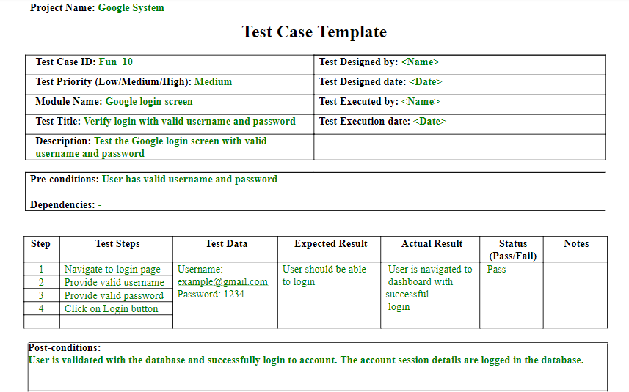
Figure 1: Test Case Template

Task A: Test Case for Black Box Testing

1. Study the Tou000ion system in http://www.touchngo.com.my.

2. Identify the possible test cases for this program. Prepare the possible test data.

3. By using the provided test case template, each student should have 3 test cases (positive and negative test cases).

4. Run the test and update your test cases.

